**THE SUPERIOR COLLEGE LAHORE**

|  |
| --- |
| chk_captcha |

**Faculty of Computer Science & IT**

**Department of Software Engineering**

**Final Year Project**

**PROJECT REPORT (Part-1)**

**[Designing and Implementation of Water supply management system]**

Project ID: **[write ID here Issued by FYP Manager]**

**Project Team**

|  |  |  |  |  |
| --- | --- | --- | --- | --- |
| **Student Name** | **Student ID** | **Program** | **Contact Number** | **Email Address** |
| Muhammad Nauman (Leader) | BCSM-F16-457 | BCSM | - | Bcsm-f16-457@superior.edu.pk |
| Muhammad Junaid Saif | BCSM-F16-429 | BCSM | - | Bcsm-f16-429@superior.edu.pk |

**[Sir Fawad Nasim]**

([Designation])

**Project Report**

**[Title of Project]**

**Change Record**

|  |  |  |  |  |
| --- | --- | --- | --- | --- |
| **Author(s)** | **Version** | **Date** | **Notes** | **Supervisor’s Signature** |
|  | 1.0 |  | <Original Draft> |  |
|  |  |  | <Changes Based on Feedback from Supervisor> |  |
|  |  |  | <Changes Based on Feedback From Faculty> |  |
|  |  |  | <Added Project Plan> |  |
|  |  |  | <Changes Based on Feedback from Supervisor> |  |
|  |  |  |  |  |
|  |  |  |  |  |
|  |  |  |  |  |
|  |  |  |  |  |
|  |  |  |  |  |

**APPROVAL**

|  |  |
| --- | --- |
| **Project Supervisor** | |
| Comments: \_\_\_\_\_\_\_\_\_\_\_\_\_\_\_\_\_\_\_\_\_\_\_\_\_\_\_\_\_\_\_\_\_\_\_\_\_\_\_\_\_\_\_\_\_\_\_\_\_\_\_\_\_\_\_\_\_\_\_\_\_\_\_\_\_\_\_ | | |
| \_\_\_\_\_\_\_\_\_\_\_\_\_\_\_\_\_\_\_\_\_\_\_\_\_\_\_\_\_\_\_\_\_\_\_\_\_\_\_\_\_\_\_\_\_\_\_\_\_\_\_\_\_\_\_\_\_\_\_\_\_\_\_\_\_\_\_\_\_\_\_\_\_\_\_\_\_ | | |
| Name:\_\_\_\_\_\_\_\_\_\_\_\_\_\_\_\_\_\_\_\_\_\_\_\_\_\_\_\_\_\_ |  | |
| Date:\_\_\_\_\_\_\_\_\_\_\_\_\_\_\_\_\_\_\_\_\_\_\_\_\_\_\_\_\_\_\_ | Signature:\_\_\_\_\_\_\_\_\_\_\_\_\_\_\_\_\_\_\_\_\_\_\_\_\_\_ | |

|  |  |
| --- | --- |
| **Project Manager** | |
| Comments: \_\_\_\_\_\_\_\_\_\_\_\_\_\_\_\_\_\_\_\_\_\_\_\_\_\_\_\_\_\_\_\_\_\_\_\_\_\_\_\_\_\_\_\_\_\_\_\_\_\_\_\_\_\_\_\_\_\_\_\_\_\_\_\_\_\_\_ | |
| \_\_\_\_\_\_\_\_\_\_\_\_\_\_\_\_\_\_\_\_\_\_\_\_\_\_\_\_\_\_\_\_\_\_\_\_\_\_\_\_\_\_\_\_\_\_\_\_\_\_\_\_\_\_\_\_\_\_\_\_\_\_\_\_\_\_\_\_\_\_\_\_\_\_\_\_\_ | |
|  |  |
| Date:\_\_\_\_\_\_\_\_\_\_\_\_\_\_\_\_\_\_\_\_\_\_\_\_\_\_\_\_\_\_\_ | Signature:\_\_\_\_\_\_\_\_\_\_\_\_\_\_\_\_\_\_\_\_\_\_\_\_\_\_ |

|  |  |
| --- | --- |
| **Head of the Department** | |
| Comments: \_\_\_\_\_\_\_\_\_\_\_\_\_\_\_\_\_\_\_\_\_\_\_\_\_\_\_\_\_\_\_\_\_\_\_\_\_\_\_\_\_\_\_\_\_\_\_\_\_\_\_\_\_\_\_\_\_\_\_\_\_\_\_\_\_\_\_ | |
| \_\_\_\_\_\_\_\_\_\_\_\_\_\_\_\_\_\_\_\_\_\_\_\_\_\_\_\_\_\_\_\_\_\_\_\_\_\_\_\_\_\_\_\_\_\_\_\_\_\_\_\_\_\_\_\_\_\_\_\_\_\_\_\_\_\_\_\_\_\_\_\_\_\_\_\_\_ | |
|  |  |
| Date:\_\_\_\_\_\_\_\_\_\_\_\_\_\_\_\_\_\_\_\_\_\_\_\_\_\_\_\_\_\_\_ | Signature:\_\_\_\_\_\_\_\_\_\_\_\_\_\_\_\_\_\_\_\_\_\_\_\_\_\_ |

# Dedication

*This work is dedicated to my . . . . . .*

# Acknowledgements

I am really thankful to my supervisor who has . . . . . . . . . .

# Executive Summary

[*A web based system to make the water filtration and supply system more technology oriented by offering a unique online website interface with easy understanding of people of all ages. This system provides easiness of getting filtered water at your doorstep, easiness in managing monthly bills of water usage, easiness in placing complaints and online order’s and easiness in choosing between high & low quality of water which may vary with prices. Online water supply management system fulfils the essential needs of a person by supplying them pure filtered water at their doorstep.* ]

# Table of Contents

[Dedication iv](#_Toc505638416)

[Acknowledgements v](#_Toc505638417)

[Executive Summary vi](#_Toc505638418)

[Table of Contents vii](#_Toc505638419)

[List of Figures ix](#_Toc505638420)

[List of Tables x](#_Toc505638421)

[Chapter 1 1](#_Toc505638422)

[Introduction 1](#_Toc505638423)

[1.1. Background 2](#_Toc505638424)

[1.2. Motivations and Challenges 2](#_Toc505638425)

[1.3. Goals and Objectives 2](#_Toc505638426)

[1.4. Literature Review/Existing Solutions 2](#_Toc505638427)

[1.5. Gap Analysis 2](#_Toc505638428)

[1.6. Proposed Solution 2](#_Toc505638429)

[1.7. Project Plan 3](#_Toc505638430)

[1.7.1. Work Breakdown Structure 3](#_Toc505638431)

[1.7.2. Roles & Responsibility Matrix 3](#_Toc505638432)

[1.7.3. Gantt Chart 3](#_Toc505638433)

[1.8. Report Outline 3](#_Toc505638434)

[Chapter 2 4](#_Toc505638435)

[Software Requirement Specifications 4](#_Toc505638436)

[2.1. Introduction 5](#_Toc505638438)

[2.1.1. Purpose 5](#_Toc505638439)

[2.1.2. Document Conventions 5](#_Toc505638440)

[2.1.3. Intended Audience and Reading Suggestions 5](#_Toc505638441)

[2.1.4. Product Scope 5](#_Toc505638442)

[2.1.5. References 6](#_Toc505638443)

[2.2. Overall Description 6](#_Toc505638444)

[2.2.1. Product Perspective 6](#_Toc505638445)

[2.2.2. Product Functions 6](#_Toc505638446)

[2.2.3. User Classes and Characteristics 6](#_Toc505638447)

[2.2.4. Operating Environment 7](#_Toc505638448)

[2.2.5. Design and Implementation Constraints 7](#_Toc505638449)

[2.2.6. User Documentation 7](#_Toc505638450)

[2.2.7. Assumptions and Dependencies 7](#_Toc505638451)

[2.3. External Interface Requirements 8](#_Toc505638452)

[2.3.1. User Interfaces 8](#_Toc505638453)

[2.3.2. Hardware Interfaces 8](#_Toc505638454)

[2.3.3. Software Interfaces 8](#_Toc505638455)

[2.3.4. Communications Interfaces 9](#_Toc505638456)

[2.4. System Features 9](#_Toc505638457)

[2.4.1. System Feature 1 9](#_Toc505638458)

[2.4.1.1. Description and Priority 9](#_Toc505638459)

[2.4.1.2. Stimulus/Response Sequences 9](#_Toc505638460)

[2.4.1.3. Functional Requirements 9](#_Toc505638461)

[2.4.2. System Feature 2 10](#_Toc505638462)

[2.4.2.1. Description and Priority 10](#_Toc505638463)

[2.4.2.2. Stimulus/Response Sequences 10](#_Toc505638464)

[2.4.2.3. Functional Requirements 10](#_Toc505638465)

[2.4.3. System Feature 3 (and so on) 11](#_Toc505638466)

[2.5. Other Nonfunctional Requirements 11](#_Toc505638467)

[2.5.1. Performance Requirements 11](#_Toc505638468)

[2.5.2. Safety Requirements 11](#_Toc505638469)

[2.5.3. Security Requirements 12](#_Toc505638470)

[2.5.4. Software Quality Attributes 12](#_Toc505638471)

[2.5.5. Business Rules 12](#_Toc505638472)

[2.6. Other Requirements 12](#_Toc505638473)

[Chapter 3 13](#_Toc505638474)

[Use Case Analysis 13](#_Toc505638475)

[3.1. Use Case Model 14](#_Toc505638476)

[3.2. Fully Dressed Use Cases 14](#_Toc505638477)

[Chapter 4 15](#_Toc505638478)

[System Design 15](#_Toc505638479)

[4.1. Architecture Diagram 16](#_Toc505638480)

[4.2. Domain Model 16](#_Toc505638481)

[4.3. Entity Relationship Diagram with data dictionary 16](#_Toc505638482)

[4.4. Class Diagram 17](#_Toc505638483)

[4.5. Sequence / Collaboration Diagram 17](#_Toc505638484)

[4.6. Operation contracts 17](#_Toc505638485)

[4.7. Activity Diagram 18](#_Toc505638486)

[4.8. State Transition Diagram 18](#_Toc505638487)

[4.9. Component Diagram 18](#_Toc505638488)

[4.10. Deployment Diagram 19](#_Toc505638489)

[4.11. Data Flow diagram [only if structured approach is used - Level 0 and 1] 19](#_Toc505638490)

[Chapter 5 20](#_Toc505638491)

[Implementation 20](#_Toc505638492)

[5.1. Important Flow Control/Pseudo codes 21](#_Toc505638493)

[5.2. Components, Libraries, Web Services and stubs 21](#_Toc505638494)

[5.3. Deployment Environment 21](#_Toc505638495)

[5.4. Tools and Techniques 22](#_Toc505638496)

[5.5. Best Practices / Coding Standards 22](#_Toc505638497)

[5.6. Version Control 22](#_Toc505638498)

[Appendices 23](#_Toc505638499)

[Appendix A: Information / Promotional Material 24](#_Toc505638500)

[Reference and Bibliography 27](#_Toc505638502)

[Index 29](#_Toc505638503)

# List of Figures

1.1 Caption of first figure of first chapter 6

1.2 Caption of second figure of first chapter 7

2.1 Caption of first figure of second chapter 14

2.2 Caption of second figure of second chapter 22

2.3 Caption of third figure of second chapter 26

5.1 Caption of first figure of fifth chapter 49

5.2 Caption of second figure of fifth chapter 49

# List of Tables

1.1 label of first table of first chapter 6

1.2 label of second table of first chapter 7

2.1 label of first table of second chapter 14

2.2 label of second table of second chapter 22

2.3 label of third table of second chapter 26

5.1 label of first table of fifth chapter 49

5.2 label of second table of fifth chapter 49

# Chapter 1

# Introduction

**Chapter 1:** Introduction

This project’s aim is to create an online web based system which will help in changing the manual workflow of our water filtration and supply system into automatic by providing our customers an easy to use interface. This system will assist the company in managing its employees, customers, stock handling and their route descriptions. Customers are also facilitated through easy approach that is getting filtered water through internet facility. Moreover this system has the ability to keep the cutomer and the business owner or the supplier in touch with the support of a chatting addon. Customer can avail all brands of filtered water by simply signing up for free and logging into his/her account, this system deals with multiple brands such as Aquafina, Doce, Neslte, Gourmet and Springley. Customers have the availability of selecting, placing order’s and getting their water delivered. System also keeps a record of the bottles delivered.

## Background

Filtered Water is an essential need for every person in today’s era, security of health is maintained. Not every person has the facility of water filtration in their homes, so to avail this facility people have to proceed to a nearby general store which sometimes becomes tiring for working community. Most of the people in our community are used to the manual system of getting filtered water so to save the distance they usually order 2 to 3 bottles to use in a long run. Sometimes the bottle wear out due to which they don’t get replaced. Due to missing bill some stores refuse from replacing as they require proof of purchased bottle from their store.

## Motivations and Challenges

**Motivation:**

* Money back guarantee will be offered to customer for if the bottle seal is broken or the water contains some impurity or the bottle is damaged.
* Deliver it at your doorstep for free is a unique idea which most customers try to avail it, to save their time, distance, energy and petrol.
* Purity Protected will be assured as if the water will be pure, customer’s health will secured.
* 3 % Discount will be offered to our regular customers for their easiness.
* Changing brand will be free of cost, if the customer wishes to change the brand of water being purchased, they are free to avail this offer for free of cost.

**Challenges:**

* Maintaining Customer Satisfaction
* Keeping the stock updated on time.
* Having Trustworthy Suppliers
* Difficult to remember which brand is being used at each house.
* Keeping a record of all the payments received from customers and paid to suppliers.

## Goals and Objectives

* Assuring the Purity of filtered water.
* Assuring the Quality of bottle used.
* Resolving customer’s queries and complaints as early as possible.
* Delivery should be in-time for better customer satisfaction.
* Keeping the records updated on time.
* Advertising for more customer’s to avail these opportunities.

## Gap Analysis

## Current State

Currently the working of water supply management goes in a way that initially the water bottles are supplied from the factory to the general stores which is then available to the customer. Although this procedure has various pros, the cons are this that customer has to check for the availability of the water bottle and wait for its arrival that can take days. This can lead to loss of dealing with the customer.

## Future State (Potential)

Implementation of supplying water online, a customer is not bound by location. It all depends on the products and services which are offered. Simply a customer can order or grab monthly membership plans just by accessing its online website or its application which requires an account registration/sign up. Fast delivery service and easy payment plans can easily convince our customer for using our online service.

## Gap (Improvement)

Due to high rate in growth of moving business to an online world, is a big advantage for our service. With this opportunity we help our customers get a hassle free service. The products and services we offer is a key to our revenue we make, so customer satisfaction is always our first priority.

## Project Plan

* Requirement Analysis.
  + Collecting Requirements.
  + Evaluation of requirements.
* Designing the Web System.
  + Front end design and Web pages design.
  + Database designing.
  + Addition of Features.
* Development of Web System.
  + Database and Payment system development.
  + Delivery System.
  + Mobile application development.
* Implementation of System.
  + Domain name and server purchase.
* Testing & Maintenance.
  + Testing of web system and application.

## Work Breakdown Structure

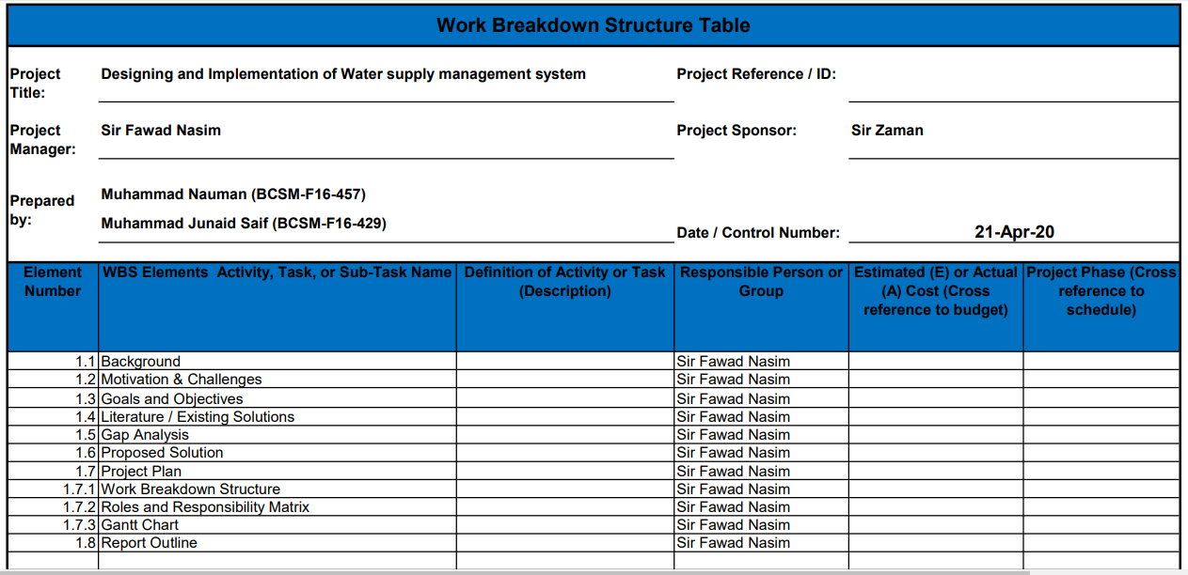

## Roles & Responsibility Matrix

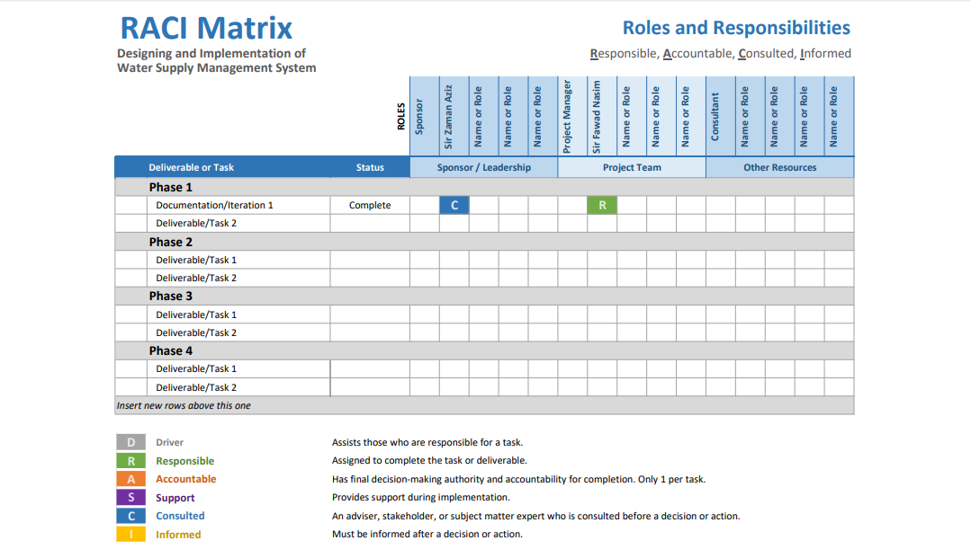

## Gantt Chart

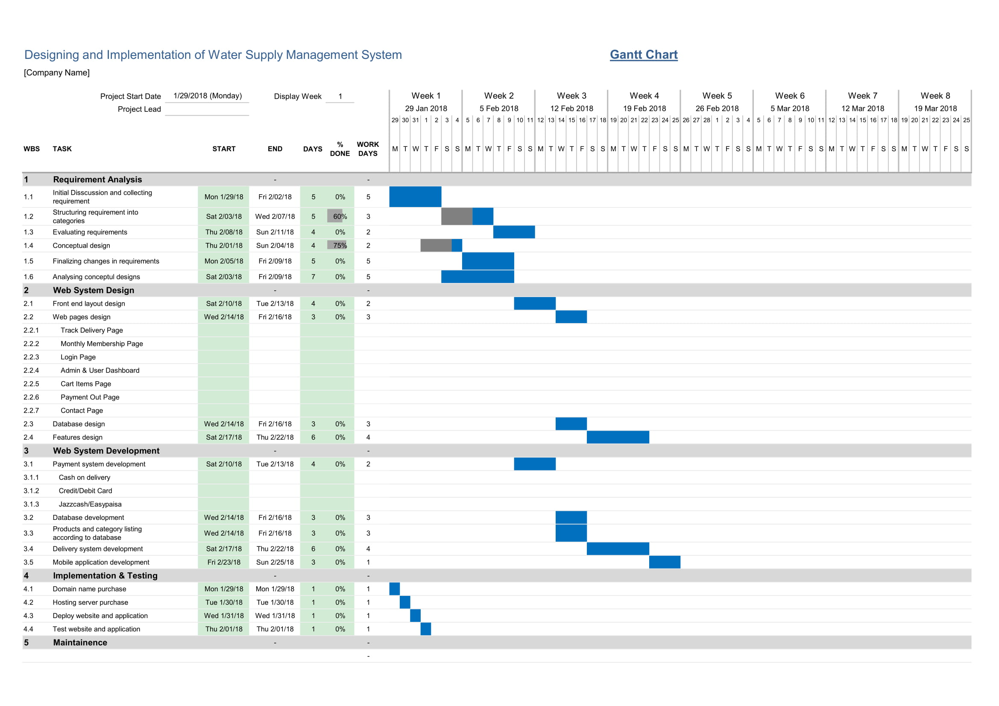

## Report Outline

An online automated water supply system to make the water filtration and supply system more technology oriented by offering a unique online website interface for interaction with easy understanding of people of all ages. This system provides easiness of getting filtered water at your doorstep, easiness in managing monthly bills of water usage, easiness in placing complaints and online order’s and easiness in choosing between high & low quality of water which may vary with prices. Online water supply management system fulfils the essential needs of a person by supplying them pure filtered water at their doorstep.

# Chapter 2

# Software Requirement Specifications

**Chapter 2:** Software Requirement Specifications



## Introduction

## Purpose

## The purpose of this Water Supply Management System is to deliver water to all customers of the system in sufficient quantity for potable drinking water and fire protection purposes, at the appropriate pressure, with minimal loss, of safe and acceptable quality, and as economically as possible. To convey water, pumps must provide working pressures, pipes must carry sufficient water, storage facilities must hold the water, and valves must open and close properly. Indeed, the carrying capacity of a water distribution system is defined as its ability to supply adequate water quantity.

## Document Conventions

* Major Priorities include:
  + Fresh Water Supply.
  + Globalization.
  + Environment Friendly Water Supply.

## Intended Audience and Reading Suggestions

Although water covers approximately 70% of the planet, only a fraction is fresh water, and even less is used as a major source of drinking water. With the continuous increase in the amount of water used in modern standards of living, the quantity of water available is decreasing. The public is beginning to understand water needs to be conserved and they must play a role in water conservation. Water is a crucial part of life, needed every day for human survival. The development of the human race has depended upon the use of clean water and societies’ ability to create clean water. Societies have been dependent upon natural resources, such as rivers, lakes, wetlands, and aquifers, to supply water to support cities, farms, and industries for centuries. The amount of water to support life, in addition to the increased amount of water used in modern standards of living, continually has increased the demand for water globally. Additionally, the amount of water available is mainly being used by irrigation, industrial, and other residential demands which clarifies our target audience.

## Product Scope

The purpose of distribution system is to deliver water to consumer with appropriate quality and quantity. Distribution system is used to describe collectively the facilities used to supply water from its source to the point of usage.

## References

https://www.sciencedirect.com/science/article/pii/S1877705814011643

## Overall Description

## Product Perspective

Water supply management system (WSMS) is a system creatively designed for the purpose of customer safety, easiness and tension-free working. Our project may be developed by using any appropriate process model for example ERP may be developed by Waterfall method at the same time. Our consumers have 24/7 access to our system which provides viewing of available water gallon products, placing an order, managing the payments, keeping a record of the order’s placed, managing customer review’s, dealing with the damaged products and listing the products in a particular order for High price and low price, most purchased and less purchased products. These are the basic requirements which grabs or attracts a customer, avail all the facilities at much more affordable rates.

## Product Functions

* Add new Products.
  + The admin and the employees of the system will have access to add new products into our system. This functionality will not be available for other actors of the system.
* View all Products.
  + This area is open to every actor in this system as they can view the products which are currently available.
* Update Product information.
  + The admin and the employees are responsible updating the information of the product as any other person will not have access to this functionality.
* Delete Products.
  + Products which are currently unavailable or multiple copies of the same product are added can be deleted by the admin and the employees of the system.

## User Classes and Characteristics

* Administrator:
  + Manage User Accounts.
    - Managing accounts of every actor in the system which means an admin can add, update, remove, view and manage the access level of each person’s user account.
  + Customer Order Management.
    - Admin has the access to all the functions that are available in order management. Admin can edit, place, return, view order’s which have been placed by customer’s.
  + Products Management.
    - Product management includes the adding, deletion, updation and viewing of products which can accessed by the admin.
  + Delivery Management.
    - This section of the section keeps a record of all the delivery details and provides a function of updating the delivery details and viewing it. The Admin has the access to all the functionality of this section.
  + Damaged Products Area.
    - This area is responsible for all the products that are faulty or if they get faulty from the customer side. The admin has the accessibility to edit, view, add and remove the records.
  + Payment Management.
    - Payment management manages the core functionalities of the mode of payment to be done when the customer places an order online. Admin can view and update any information required in this section.
  + Contact Support.
    - This sections allows the customer’s to communicate with the admin and vice versa if any problem persists regarding our system.
* Employees:
  + Account Registration.
    - Account Registration provides facilities to employees which are registering an account, log in, log out and account deactivation.
  + Customer Order Management.
    - Employees also has access to all the functions that are available in order management. Employees can edit, place, return, view order’s which have been placed by customer’s.
  + Products Management.
    - Product management includes the adding, deletion, updation and viewing of products which can accessed by the employees.
  + Delivery Management.
    - This section of the section keeps a record of all the delivery details and provides a function of updating the delivery details and viewing it. The employees has the access to all the functionality of this section.
  + Damaged Products Area.
    - This area is responsible for all the products that are faulty or if they get faulty from the customer side. The employees has the accessibility to edit, view, add and remove the records.
  + Payment Management.
    - Payment management manages the core functionalities of the mode of payment to be done when the customer places an order online. Admin can view and update any information required in this section.
  + Contact Support.
    - This sections allows the customer’s to communicate with the employees and vice versa if any problem persists regarding our system.
* Customer:
  + Account Registration.
    - Account Registration provides facilities to customer’s which are registering an account, log in, log out and account deactivation.
  + Customer Order Placement.
    - Customer’s also has access to all the functions that are available in order management. Customers can edit, place, return, view order’s which have been placed by them.
  + View Products.
    - To purchase our products this section is the most essential as it display’s all of the products that are currently available.
  + Delivery.
    - This section of the section keeps a record of all the delivery details and provides a function of updating the delivery details and viewing it. The employees has the access to all the functionality of this section.
  + Damaged Products Area.
    - This area is responsible for all the products that are faulty or if they get faulty from the customer side. The employees has the accessibility to edit, view, add and remove the records.
  + Payment.
    - Payment management manages the core functionalities of the mode of payment to be done when the customer places an order online. Admin can view and update any information required in this section.
  + Contact Support.
    - This sections allows the customer’s to communicate with the admin and vice versa if any problem persists regarding the system.
* Delivery Boy:
  + Account Registration
    - Account Registration provides facilities to customer’s which are registering an account, log in, log out and account deactivation.
  + View Delivery Details.
    - This section of the section keeps a record of all the delivery details and provides a function of viewing the delivery details.

## Operating Environment

This product is developed for web based application. The tools and technique which are used for this development are:

* C#
* Java Script
* ASP.NET
* SQL server
* HTML
* CSS
* Visual studio

## Design and Implementation Constraints

Our greatest limitation will be the testing of the water which is being imported from different companies as the products we receive are seal packed which resists us from assuring the quality of the water being received in our products. This limitation can affect our customer’s health. So to maintain our level of quality we can get the assurity of the product from the company we purchase which can help remove our limitation.

## User Documentation

* Introduction
  + Overview
  + Quick Installation Guide
  + Online Help
* Get Started
  + Workspace Basics
  + Set Preferences
  + First Use Steps
    - Account Handling
      * Register New Account.
      * Log In.
      * Log Out.
      * Deactivation of Account permanently.
    - Placing Order.
      * Adding items to cart.
    - Check Out.
      * Payment Method.
    - Delivery Handling.
      * Providing Details.
    - Comments & Reviews.
* Appendices.
* Contact / Support.

## External Interface Requirements

## 

## User Interfaces

Our user interface will be built using Bootstrap which will provide us features to enhance the working of our web application. Our UI will be an easy to use interface which will be understandable by people of every age, language will not be a barrier for our customers as we will be displaying understandable icons with text and if not customer has the accessibility to choose language for better understanding and easy usage.

## Software Interfaces

Our project will require a database to record all our customer’s data and our sales records, for that we will be using SQL Server on our back end to maintain the required data. We will also be using JavaScript and ASP.net to perform our on screen tasks for example: Animation handling, Error pop-ups and much more. On the other hand, Bootstrap will help us in designing our front end of our project.

## Communications Interfaces

The Contact section of our project is a gateway between the customer and our system. This section includes a form which will require customer’s Full Name, Email ID, Description of the problem, when submitted with required information then it will forwarded to our staff which will respond on urgent basis to help our customer’s.

## Other Nonfunctional Requirements

## Performance Requirements

To make our system to meet the required performance targets we have to clearly look over to the performance requirements. Assessing the performance of a system we have to specify the following area’s:

* System’s Response time.
  + The response time is the major factor as customers always hate delay’s so the response of our system should stay constant. System’s which have to support less number of customers can recover the cost of response delay’s but in our case we won’t be able to bear as we don’t contain limit for customer’s.
* Workload.
  + Workload specifies that is the system capable of handling customer’s more than 50,000. Our system should be able to support 3 to 4 pages per second. Fulfilling these requirements might meet the levels of High management systems but it clearly not defines the work that the system must support. Workload should be handled according to the database and the amount of online users a server can handle.
* Scalability.
  + Scalability simply defines our system’s performance when the workload increases more than expected and what is the current response time and how our system responds to that situation, that position clearly identifies the performance of our system. To maintain the scalability is that the response time requirements should meet as the workload changes.

## Safety Requirements

* Health safety.
  + Health is our first priority as the water being supplied in our products should be clean and impurity free for safety measures and we believe that the water being supplied is safe to drink and if any problem persists our team is fully responsible and we will provide full support to ensure our customer’s safety.
* Usage of safe material for products.
  + The packaging of our product will be harmless and environment friendly which will ensure the safety of our customers.
* Maintaining customer satisfaction.
  + By taking all possible safety precautions we believe in customer satisfaction and will provide full support to ensure the safety of our customer’s.

## Security Requirements

One or more requirements about protection of your system and its data. The measurement can be expressed in a variety of ways (effort, skill level and time) to break into the system.  Do not discuss solutions (e.g. passwords) with any stranger. If a user forgets his password, without proper verification he won’t be able to log in to that account, he has to contact admin. Privacy of every account will be our responsibility.

## Software Quality Attributes

Software quality should be maximized at its earliest as one error can lead to many errors. So we should increase the adaptability, availability, correctness, flexibility, portability, reliability, reusability, robustness and usability of our system to make it user friendly and make its performance better.

## Business Rules

* User must finish with account registration to perform any operation.
* User has to follow the Terms and Conditions.
* The Website address should be easy to remember.
* Contact information.
* FAQ’s for our customers.
* About us.

## Other Requirements

There are no other requirements or any specific thing needed to run the website or to run it in development phase, all of the information is mentioned above for better understanding.

# Chapter 3

# Use Case Analysis

**Chapter 3:** System Analysis

## Use Case Model

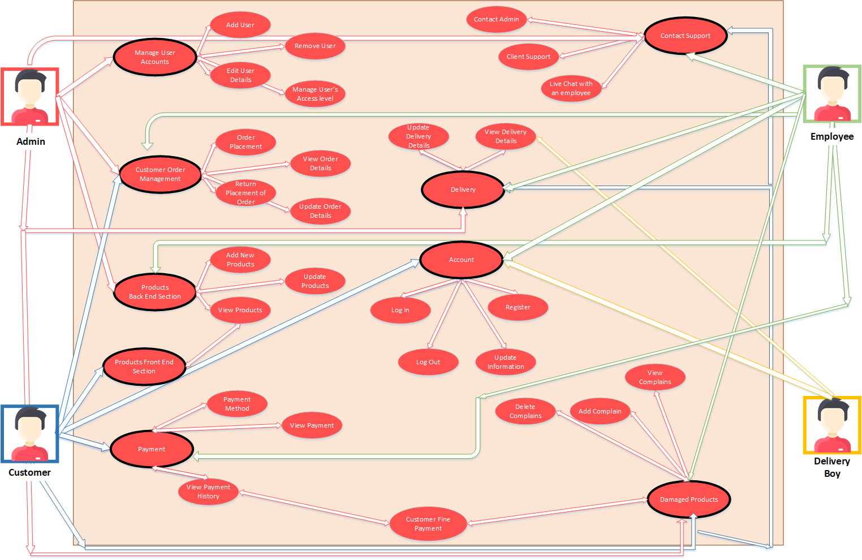

## Fully Dressed Use Cases

* Admin User Accounts Management:

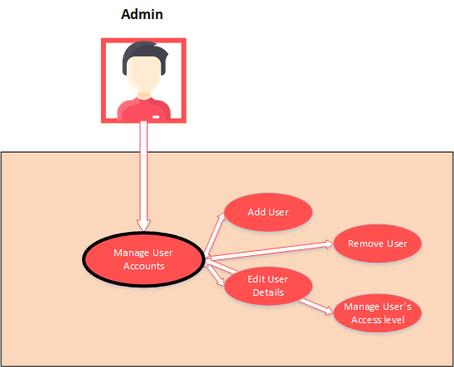

* Admin Customer Order Management:

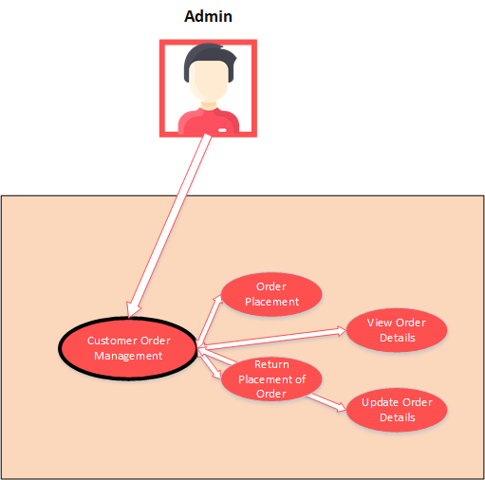

* Admin Products Section:

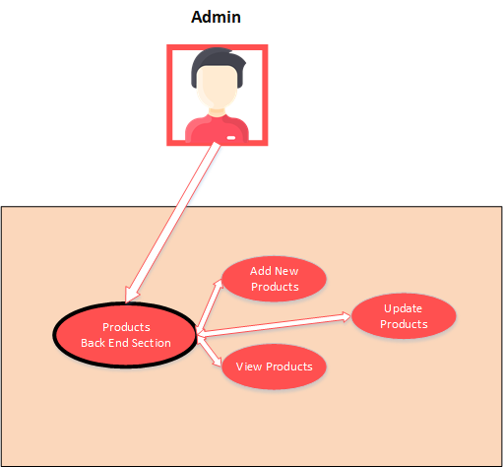

* Admin Contact:

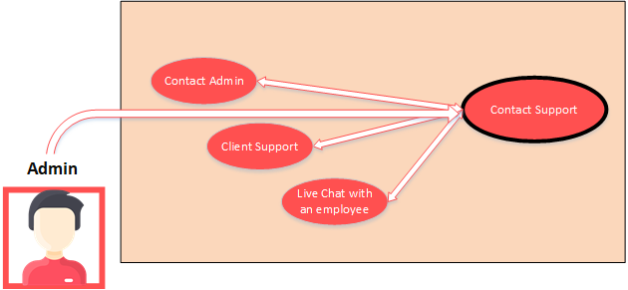

* Admin Delivery section:

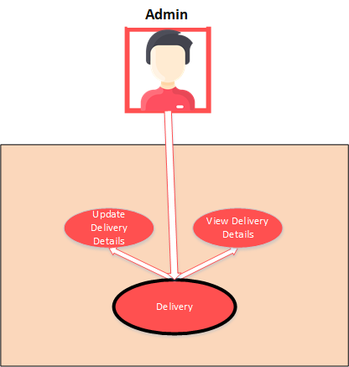

* Admin Damaged Products:

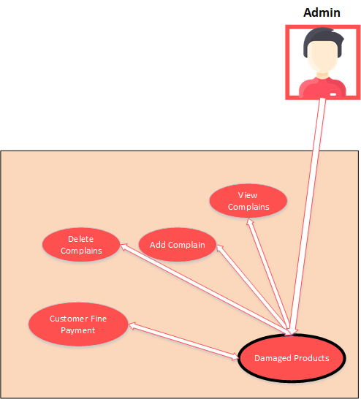

* Customer Order Management:

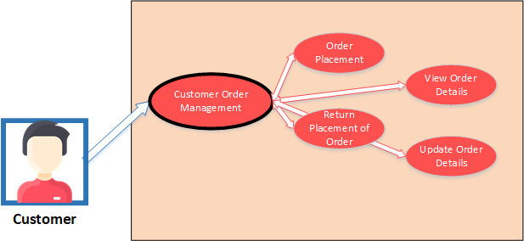

* Customer Products View:

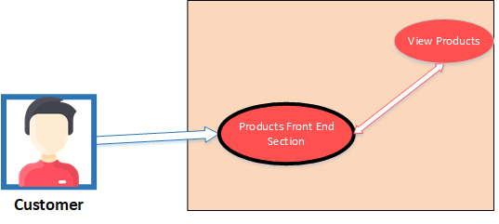

* Customer Account Registration:

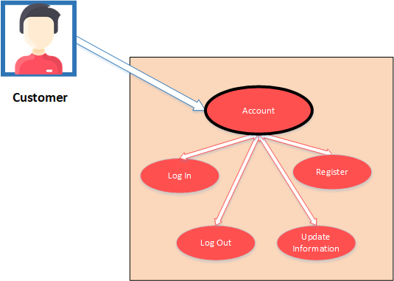

* Customer Payment area:

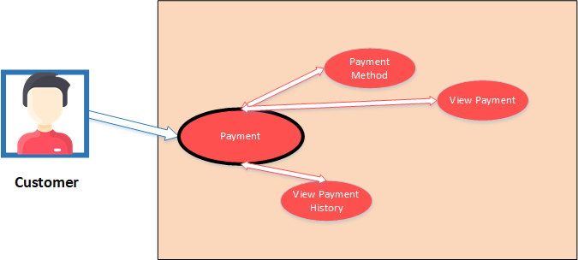

* Employee Payment area:

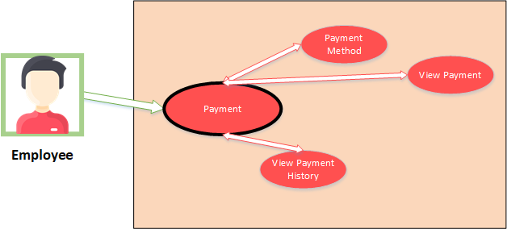

* Employee Account Registration:

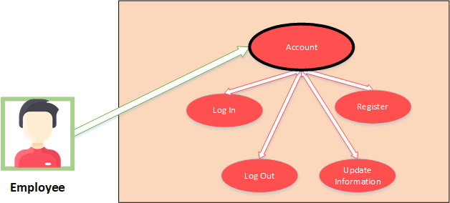

* Employee Delivery Management:

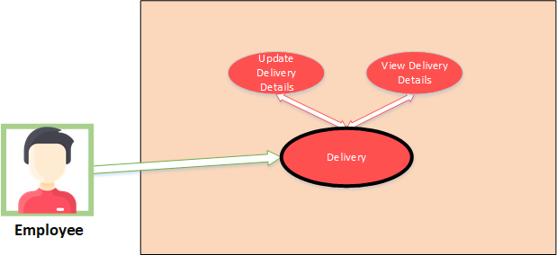

# Chapter 4

# System Design

**Chapter 4:** System Design

[Paragraph Text 12 pt, Calibri, 1.5 Line Spacing, Justified]

[*Between 4 to 8 lines describe what is this chapter all about*]

## Architecture Diagram

[Paragraph Text 12 pt, Calibri, 1.5 Line Spacing, Justified]

## Domain Model

[Paragraph Text 12 pt, Calibri, 1.5 Line Spacing, Justified]

## Entity Relationship Diagram with data dictionary

[Paragraph Text 12 pt, Calibri, 1.5 Line Spacing, Justified]

## Class Diagram

[Paragraph Text 12 pt, Calibri, 1.5 Line Spacing, Justified]

## Sequence / Collaboration Diagram

[Paragraph Text 12 pt, Calibri, 1.5 Line Spacing, Justified]

## Operation contracts

[Paragraph Text 12 pt, Calibri, 1.5 Line Spacing, Justified]

## Activity Diagram

[Paragraph Text 12 pt, Calibri, 1.5 Line Spacing, Justified]

## State Transition Diagram

[Paragraph Text 12 pt, Calibri, 1.5 Line Spacing, Justified]

## Component Diagram

[Paragraph Text 12 pt, Calibri, 1.5 Line Spacing, Justified]

## Deployment Diagram

[Paragraph Text 12 pt, Calibri, 1.5 Line Spacing, Justified]

## Data Flow diagram [*only if structured approach is used - Level 0 and 1*]

[Paragraph Text 12 pt, Calibri, 1.5 Line Spacing, Justified]

# Chapter 5

# Implementation

**Chapter 5:** Implementation

[Paragraph Text 12 pt, Calibri, 1.5 Line Spacing, Justified]

[*Between 4 to 8 lines describe what is this chapter all about*]

## Important Flow Control/Pseudo codes

[Paragraph Text 12 pt, Calibri, 1.5 Line Spacing, Justified]

## Components, Libraries, Web Services and stubs

[Paragraph Text 12 pt, Calibri, 1.5 Line Spacing, Justified]

## Deployment Environment

[Paragraph Text 12 pt, Calibri, 1.5 Line Spacing, Justified]

## Tools and Techniques

[Paragraph Text 12 pt, Calibri, 1.5 Line Spacing, Justified]

## Best Practices / Coding Standards

[Paragraph Text 12 pt, Calibri, 1.5 Line Spacing, Justified]

## Version Control

[Paragraph Text 12 pt, Calibri, 1.5 Line Spacing, Justified]

# Appendices

# Appendix A: Information / Promotional Material

[Paragraph Text 12 pt, Calibri, 1.5 Line Spacing, Justified]

[*Between 4 to 8 lines describe what is this appendix all about*]

* 1. **Broacher**

* 1. **Flyer**
  2. **Standee**
  3. **Banner**
  4. **First Level heading [16 pt, Calibri, Bold, Left aligned]**

[Paragraph Text 12 pt, Calibri, 1.5 Line Spacing, Justified]

* + 1. **Second level heading [14 pt, Calibri, Bold, Left aligned]**

[Paragraph Text 12 pt, Calibri, 1.5 Line Spacing, Justified]

* + - 1. **Third level heading [12 pt, Calibri, Bold, Left aligned]**

[Paragraph Text 12 pt, Calibri, 1.5 Line Spacing, Justified]

# Appendix [no.]: Appendix Title

[Paragraph Text 12 pt, Calibri, 1.5 Line Spacing, Justified]

[*Between 4 to 8 lines describe what is this chapter all about*]

* 1. **First Level heading [16 pt, Calibri, Bold, Left aligned]**

[Paragraph Text 12 pt, Calibri, 1.5 Line Spacing, Justified]

* + 1. **Second level heading [14 pt, Calibri, Bold, Left aligned]**

[Paragraph Text 12 pt, Calibri, 1.5 Line Spacing, Justified]

* + - 1. **Third level heading [12 pt, Calibri, Bold, Left aligned]**

[Paragraph Text 12 pt, Calibri, 1.5 Line Spacing, Justified]

# Reference and Bibliography

**Reference and Bibliography**

[1] M. Sher, M. Rehman, “*Title of the Paper*” Conference name/Journal Name, Edition, Volume, Issue, ISBN/ISSN, PP, Publisher/City-Country, Year.

[2] ……

# Index

**Index**

**[A]**

**[B]**

**[C]**